**Ex27Chp6andEx3Chp7**

**Exercise 27-Chapter 6**

In Fig. 6-36 we saw that in addition to the 32-bit acknowledgement field, there is an ACK bit in the fourth word. Does this really add anything? Why or why not?

It is used to establish a connection with the three-way handshake. It replaces the 32 bit field that is needed to communicate with and adds a way for the ends to know who they are communicating with.

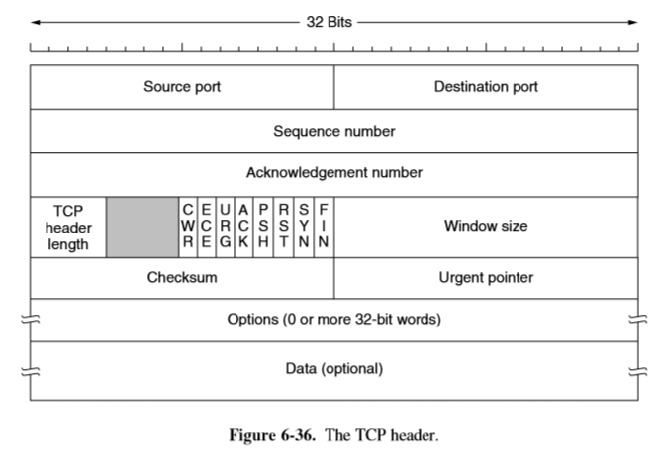

**Exercise 3-Chapter 7**

Consider a situation in which a cyberterrorist makes all the DNS servers in the world crash simultaneously. How does this change one’s ability to use the Internet?

It would not let you be able to access web pages using their URL or links, it only allows you to access them via their IP address.